Impact of Gambling Addiction Games on the Mobile Gaming Market in India

A PROJECT REPORT

*Submitted by*

Athul Ganesh.J [RA211105101003] Nikhilesh Ram [RA2111051010016]

Immanuel Adaikala Russo [RA2111051010032] Shyam Ganesh K [RA2111051010047]

*Under the Guidance of*

(Dr.SV. Shri Bharathi)

(Assistant Professor, Data Science and Business Systems)

*in partial fulfillment of the requirements for the degree of*

BACHELOR OF TECHNOLOGY

in

COMPUTER SCIENCE ENGINEERING

with specialization in (GAMING TECHNOLOGY)



DEPARTMENT OF DATA SCIENCE AND BUSINESS SYSTEMS

COLLEGE OF ENGINEERING AND TECHNOLOGY

SRM INSTITUTE OF SCIENCE AND TECHNOLOGY

KATTANKULATHUR- 603 203

NOVEMBER 2024

Department of Data Science and Bussiness System

#### SRM Institute of Science & Technology Own Work* Declaration Form

This sheet must be filled in (each box ticked to show that the condition has been met). It must be signed and dated along with your student registration number and included with all assignments you submit – work will not be marked unless this is done.

To be completed by the student for all assessments

**Degree/ Course : B.tech/CSE with specialization in Gaming Technology**

**Student Name :Athul Ganesh, Nikhilesh Ram, Immanuel Adaikala Russo, Shyam Ganesh K**

**Registration Number**

**:RA2111051010003, RA2111051010016, RA2111051010032, RA2111051010047**

**Title of Work : Impact of Gambling Addiction Games on the Mobile Gaming Market in India**

I / We hereby certify that this assessment compiles with the University’s Rules and Regulations relating to Academic misconduct and plagiarism**, as listed in the University Website, Regulations, and the Education Committee guidelines.

I / We confirm that all the work contained in this assessment is my / our own except where indicated, and that I / We have met the following conditions:

* Clearly referenced / listed all sources as appropriate
* Referenced and put in inverted commas all quoted text (from books, web, etc)
* Given the sources of all pictures, data etc. that are not my own
* Not made any use of the report(s) or essay(s) of any other student(s) either past or present
* Acknowledged in appropriate places any help that I have received from others (e.g. fellow students, technicians, statisticians, external sources)
* Compiled with any other plagiarism criteria specified in the Course handbook / University website

I understand that any false claim for this work will be penalized in accordance with the University policies and regulations.

|  |
| --- |
| **DECLARATION:** |
| I am aware of and understand the University’s policy on Academic misconduct and plagiarism and I certify that this assessment is my / our own work, except where indicated by referring, and that I have followed the good academic practices noted above. |
| If you are working in a group, please write your registration numbers and sign with the date for every student in your group. |



SRM INSTITUTE OF SCIENCE AND TECHNOLOGY KATTANKULATHUR – 603 203

BONAFIDE CERTIFICATE

Certified that 18CSP107L - Minor Project] report titled “**Impact of Gambling Addiction Games on the Mobile Gaming Market in India** ” is the bonafide work of “ **Athul Ganesh.J [RA2111051010003], Nikhilesh Ram [RA2111051010016], Immanuel Adaikala Russo [RA2111051010032], Shyam Ganesh K [RA2111051010047]”** who carried out the project work[under my supervision. Certified further, that to the best of my knowledge the work reported herein does not form any other project report or dissertation on the basis of which a degree or award was conferred on an earlier occasion on this or any other candidate.

<<Signature >> <<Signature >>

**SIGNATURE SIGNATURE**

**Dr.SV. Shri Bharathi DR. V. Kavitha**

**SUPERVISOR**

[ Assistant Professor, Data Science and Business Systems]

[DEPARTMENT

OF Data Science and Bussiness System]

**PROFESSOR &HEAD**

DEPARTMENT OF

DATA SCIENCE AND BUSSINESS SYSTEM

# ACKNOWLEDGEMENTS

We express our humble gratitude to **Dr. C. Muthamizhchelvan**, Vice-Chancellor, SRM InstituteofScience and Technology, for the facilities extended for the project work and his continued support.

We extend our sincere thanks to **Dr. T. V. Gopal ,** Dean-CET, SRM Institute of Science and Technology, for his invaluable support.

We wish to thank **Dr. Revathi Venkataraman**, Professor and Chairperson, School of Com puting, SRM Institute of Science and Technology, for her support throughout the project work.

We encompass our sincere thanks to , **Dr. M. Pushpalatha**, Professor and Associate Chairperson, School of Computing and **Dr. C.Lakshmi,** Professor and Associate Chairperson, School of Computing, SRM Institute of Science and Technology, for their invaluable support.

We are incredibly grateful to our Head of the Department**, DR. V. Kavitha**, Professor, Department of DATA SCIENCE AND BUSSINESS SYSTEM SRM Institute of Science and Technology, for her suggestions and encouragement at all the stages of the project work.

We want to convey our thanks to our Project Coordinators, ........., Panel Head, **..Dr.S.Ganesh Kumar,** and Panel Members,, **Dr.A.Syed, Ismail, Dr.R.Jayaraj, Dr.S.V.Shri Bharathi, Dr.K.Panimalar**................, Department of Computational Intelligence, SRM Institute of Science and Technology, for their inputs during the project reviews and support.

We register our immeasurable thanks to our Faculty Advisor, .....**Dr.Chinnasamy.A** ,

Department of DATA SCIENCE AND BUSSINESS SYSTEM, SRM Institute of Science and Technology, for leading and helping us to complete our course.

Our inexpressible respect and thanks to our guide, **............ Dr.SV. Shri Bharathi** , Department of

DATA SCIENCE AND BUSSINESS SYSTEM, SRM Institute of Science and Technology, for providing us with an opportunity to pursue our project under his / her mentorship. He / She provided us with the freedom and support to explore the research topics of our interest. His / Her passion for solving problems and making a difference in the world has always been inspiring.

We sincerely thank all the staff and students of DATA SCIENCE AND BUSSINESS SYSTEM, School of Computing, S.R.M Institute of Science and Technology, for their help during our project. Finally, we would like to thank our parents, family members, and friends for their unconditional love, constant support and encouragement

**Athul Ganesh.J [RA2111051010003] Nikhilesh Ram [RA2111051010016]**

**Immanuel Adaikala Russo [RA2111051010032] Shyam Ganesh K [RA2111051010047]**

# ABSTRACT

The Indian mobile gaming market has experienced remarkable growth over the past decade, fueled by the increasing affordability of smartphones, extensive internet penetration, and a burgeoning interest in digital entertainment. This sector is projected to reach a valuation of $5 billion by 2025, positioning India as one of the world's fastest-growing mobile gaming markets. However, alongside this growth, a parallel rise in mobile gambling applications has introduced complex challenges, blurring the lines between gaming and gambling. Mobile gambling, often embedded within or adjacent to traditional mobile games, has raised significant concerns around gambling addiction, consumer welfare, and public health.

This study investigates the impact of gambling addiction on India's mobile gaming market, focusing on how the intersection of gaming and gambling affects user behavior, industry dynamics, and regulatory structures. Specifically, we analyze the psychological mechanisms that drive users toward compulsive behavior within these hybrid gaming-gambling environments, including the role of in-game incentives, loot boxes, and reward mechanisms that mimic gambling experiences. This convergence can alter consumer perceptions of mobile gaming, potentially stigmatizing an otherwise booming industry and affecting user trust and engagement.

Furthermore, the study explores the regulatory landscape in India, where existing laws struggle to keep pace with the rapid evolution of digital gaming and gambling platforms. Inadequate regulation around in-app gambling features poses risks not only to vulnerable populations but also to the reputation of legitimate gaming companies. We highlight the need for clearer legal frameworks that distinguish between gaming and gambling while ensuring user protections.

In summary, this paper provides insights into the economic, behavioral, and regulatory ramifications of gambling addiction within India's mobile gaming industry. Our findings underscore the importance of responsible gaming practices, consumer education, and updated regulatory guidelines to sustain the growth of India’s mobile gaming market while safeguarding users from the risks associated with gambling addiction.

|  |  |  |
| --- | --- | --- |
| **TABLE OF CONTENTS** |  |  |
| **ABSTRACT** | **v** |
| **TABLE OF CONTENTS** | **vi** |
| **LIST OF FIGURES** | **vii** |
| **LIST OF TABLES** | **viii** |
|  |  | **.** |
| **1 INTRODUCTION** | **1** |  |
| 1.1 General (Introduction to Project) | 2 |  |
| 1.2 Motivation | 3 |  |
| 1.3 Sustainable Development Goal of the Project | 4 |  |
| 1.4 Product Vision Statement | 5 |  |
| 1.5 Product Goal | 6 |  |
| 1.6 Product Backlog (Key User Stories with Desired Outcomes) | 7 |  |
| 1.7 Product Release Plan | 8 |  |
| **2 SPRINT PLANNING AND EXECUTION** | **9** |  |
| **2.1 Sprint 1** | **10** |  |
| 2.1.1 Sprint Goal with User Stories of Sprint 1 | 11 |  |
| 2.1.2 Functional Document | 12 |  |
| 2.1.3 Architecture Document | 13 |  |
| 2.1.4 UI Design | 14 |  |
| 2.1.5 Functional Test Cases | 15 |  |
| 2.1.6 Daily Call Progress | 16 |  |
| 2.1.7 Committed vs Completed User Stories | 17 |  |
| 2.1.8 Sprint Retrospective | 18 |  |
|  | 19 |  |

1. **RESULTS AND DISCUSSIONS 20**
   1. Project Outcomes (Justification of outcomes and how they align 21

with the goals)

* 1. Committed vs Completed User Stories 23

**4 CONCLUSIONS & FUTURE ENHANCEMENT 24**

**APPENDIX**

1. **PATENT DISCLOSURE FORM**
2. **SAMPLE CODING**
3. **PLAGIARISM REPORT**

# CHAPTER 1 INTRODUCTION

## Introduction to Impact of Gambling Addiction Games on the Mobile Gaming Market in India:

The Indian mobile gaming industry is on track for remarkable growth, with projections indicating it could reach a $5 billion valuation by 2025. This surge is driven by increasing smartphone penetration, affordable data plans, and a young, tech-savvy population eager for interactive entertainment. However, this rapid expansion comes with a shadow: the simultaneous rise of mobile gambling, which poses significant risks to both individual users and the industry at large.

As mobile gambling becomes more accessible through apps and online platforms, it also becomes more addictive. The convenience of gambling from a personal device, coupled with targeted advertisements and engaging interfaces, can make it easy for users to lose track of time and money. This accessibility may lead to gambling addiction among a growing number of users, raising public health concerns, especially in a country like India, where mental health support is still under-resourced.

The potential for widespread gambling addiction could lead to societal backlash, which might cast a negative light on the broader gaming industry, even though mobile gaming and gambling are distinct. Lawmakers and regulators could respond with restrictive policies that impact both sectors, inadvertently affecting innocent gaming ventures and their audiences. Furthermore, public perception might shift, associating all gaming apps with addictive and potentially harmful behavior, thereby discouraging users and investors from supporting the industry.

To sustain growth in the gaming sector, it is crucial for stakeholders to promote responsible gaming practices, advocate for clear distinctions between gaming and gambling, and support initiatives that monitor and mitigate addiction risks. Industry self-regulation, along with proactive policies, could help ensure that the mobile gaming industry thrives without being overshadowed by the challenges posed by mobile gambling.

## Motivation

The rise of gambling addiction is increasingly linked to mobile games incorporating gambling-like elements, such as loot boxes, chance-based rewards, or microtransactions, creating a blurred line between casual gaming and gambling. This intersection is fostering a negative public perception that can significantly damage the mobile gaming industry's reputation, particularly in a country like India, where the gaming culture is still in its nascent stages.

When users or their families experience the negative consequences of gambling addiction—such as financial losses, mental health issues, or compulsive behaviors—there’s a tendency to generalize these risks to the entire gaming industry. This stigmatization can reduce user trust, as people begin to associate mobile games with exploitative practices rather than entertainment or skill-building. As a result, fewer people may engage with mobile gaming apps, and existing users might be more cautious, which can slow user acquisition and retention, vital elements for growth in this competitive sector.

In India, where mobile gaming has only recently become mainstream, building and maintaining a positive image is essential to ensure continued growth and investment. A negative perception stemming from gambling-related issues could lead parents, policymakers, and the media to criticize mobile games, even those unrelated to gambling, as potentially harmful to society. If this stigma takes root, it may spur stricter regulations, limit monetization opportunities, and deter international gaming companies from entering the Indian market.

For sustained success, it's critical for the mobile gaming industry in India to foster transparency, educate users about the distinction between gambling and gaming, and promote responsible gaming practices. This proactive approach can help the industry grow while minimizing the risk of public backlash. Companies that actively separate themselves from gambling-like mechanics and demonstrate ethical monetization practices are more likely to gain user trust and loyalty, laying the foundation for a robust and sustainable market.

## Sustainable Development Goal of the Project

* Conduct research on mobile gambling addiction, including its causes, triggers, and effects on individuals.
* Define Features: Decide on the core features of the app lock. Common features might include:
* Blocking access to gambling apps and websites.
* Time-based restrictions (e.g., limiting usage during specific hours).
* Password protection or biometric lock.
* Notifications and alerts to discourage gambling.
* Integration with support systems like hotlines or therapy services.
* Legal Considerations: Ensure that your app complies with local and international laws, particularly around user privacy and app permissions.

.

## Product Vision Statement

### Audience:

* + - * Primary Audience: Individuals aiming to limit their gambling habits and improve digital wellbeing.
      * Secondary Audience: Family members, guardians, and therapists interested in supporting safe device use through app monitoring and restriction features.

### Needs:

* + - * Primary Needs:
        + Effective and secure locking mechanisms for gambling applications.
        + Real-time notifications and monitoring features to track access attempts.
        + User-friendly setup for managing app locks and tracking device usage patterns.
      * Secondary Needs:
        + Detailed logging and reporting tools to help users review their progress.
        + Customizable settings for managing access to multiple apps.
        + Support for user preferences in lock options, notifications, and usage tracking.

### Products:

* + - * Core Product: An addiction management tool providing app detection, locking, access tracking, and notifications focused on gambling apps.
      * Additional Features:
        + Customizable lock mechanisms, including PIN, pattern, and biometric authentication.
        + Configurable notifications to alert users of any app access attempts.
        + Reporting features that allow users to review access history for each locked app.

### Values:

* + - * Core Values:
        + Control: Enabling users to manage their app usage and mitigate addiction risks.
        + Security: Ensuring user data is private and secure with reliable authentication methods.
        + Awareness: Helping users build awareness of their habits through real- time tracking and notifications.
      * Differentiators:
        + Customizable App Locking: Providing flexible lock options tailored to user needs.
        + Real-Time Access Monitoring: Immediate notifications for access attempts.
        + Progress Tracking: Offering detailed reports to support users’ efforts in maintaining healthier device habits.

## 1.4 Product Goal

The primary goal of the App Lock project is to empower individuals to manage their gambling app usage proactively and responsibly. By offering secure and customizable app-locking, real- time monitoring, and insightful usage tracking, the app provides users with the tools to limit access to gambling applications and build healthier digital habits. Designed to support addiction

management and foster digital wellbeing, the App Lock app aims to create a safe and supportive environment where users can regain control over their app usage. Ultimately, this product aspires to contribute to a healthier relationship between users and their devices by promoting self- awareness, reducing compulsive behavior, and enhancing overall mental health..

## 1.6 Product Backlog

|  |  |
| --- | --- |
| **S.No** | **User Stories of AI E-Learning Application** |
| #US 1 | As a new user, I want an easy registration process to access the app lock features for managing gambling app usage. |
| #US 2 | As a new user, I want to create a secure profile after registration so that I can customize  my app locking and tracking settings. |
| #US 3 | As a user, I want the app to automatically detect gambling applications on my device so  that I can quickly identify and lock them |
| #US 4 | As a user, I want to lock specific gambling apps using various methods (PIN, pattern,  biometric) to prevent unauthorized access. |
| #US 5 | As a user, I want real-time notifications whenever a locked app is accessed, so I can stay  aware of my usage habits. |
| #US 6 | As a user, I want to view a history of access attempts, including successful and failed  logins, to monitor my app interactions. |
| #US 7 | As a user, I want to configure the app to automatically re-lock gambling apps after a period of inactivity to ensure continuous protection. |
| #US 8 | As a user, I want daily and weekly reports on my app usage to track my progress and gain insights into my habits. |
| #US 9 | As a user, I want the ability to set reminders for the locked apps, helping me manage my  time and prevent compulsive access |
| #US 10 | As a user, I want to customize the type and frequency of notifications so that I receive only  relevant alerts. |

|  |  |
| --- | --- |
| #US 11 | As a user, I want to provide feedback on the app’s features and usability to help improve its functionality and user experience. |

This backlog captures key user stories for the App Lock project, emphasizing usability, security, and habit-tracking features. Let me know if you'd like to add or adjust any item

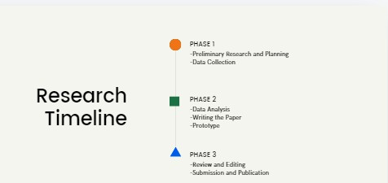

.f igure 1.1 MS Planner Board of App lock Application

## 1.7 Product Release Plan

The following Figure 1.2 depicts the release plan of the project

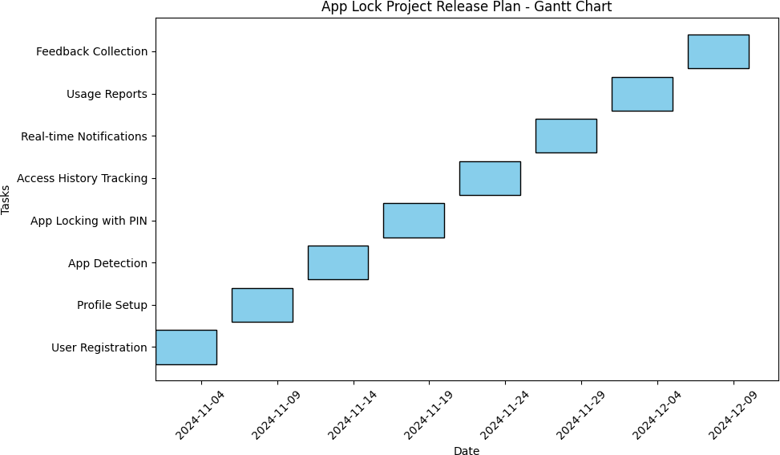

Figure 1.2 Release plan of App-LockApplication

# CHAPTER 2

**SPRINT PLANNING AND EXECUTION**

## Sprint 1

* + 1. Sprint Goal with User Stories of Sprint 1

The goal of the first sprint is to create the user registration and authentication system, and to enable initial functionalities such as app detection for identifying gambling apps on the user’s device.

#### Table 2.1 Detailed User Stories of sprint 1

|  |  |
| --- | --- |
| **S.NO** | **Detailed User Stories** |
| US #1 | As a new user, I want to register securely on the app so that I can access the app lock  features |
| US #2 | As a new user, I want to set up a secure profile with authentication (PIN, pattern, or  biometric) so that my settings are protected. |
| US #3 | As a user, I want the app to automatically detect installed gambling apps so that I can  choose which apps to monitor and lock. |

Planner Board representation of user stories are mentioned below figures 2.1,2.2 and 2.3

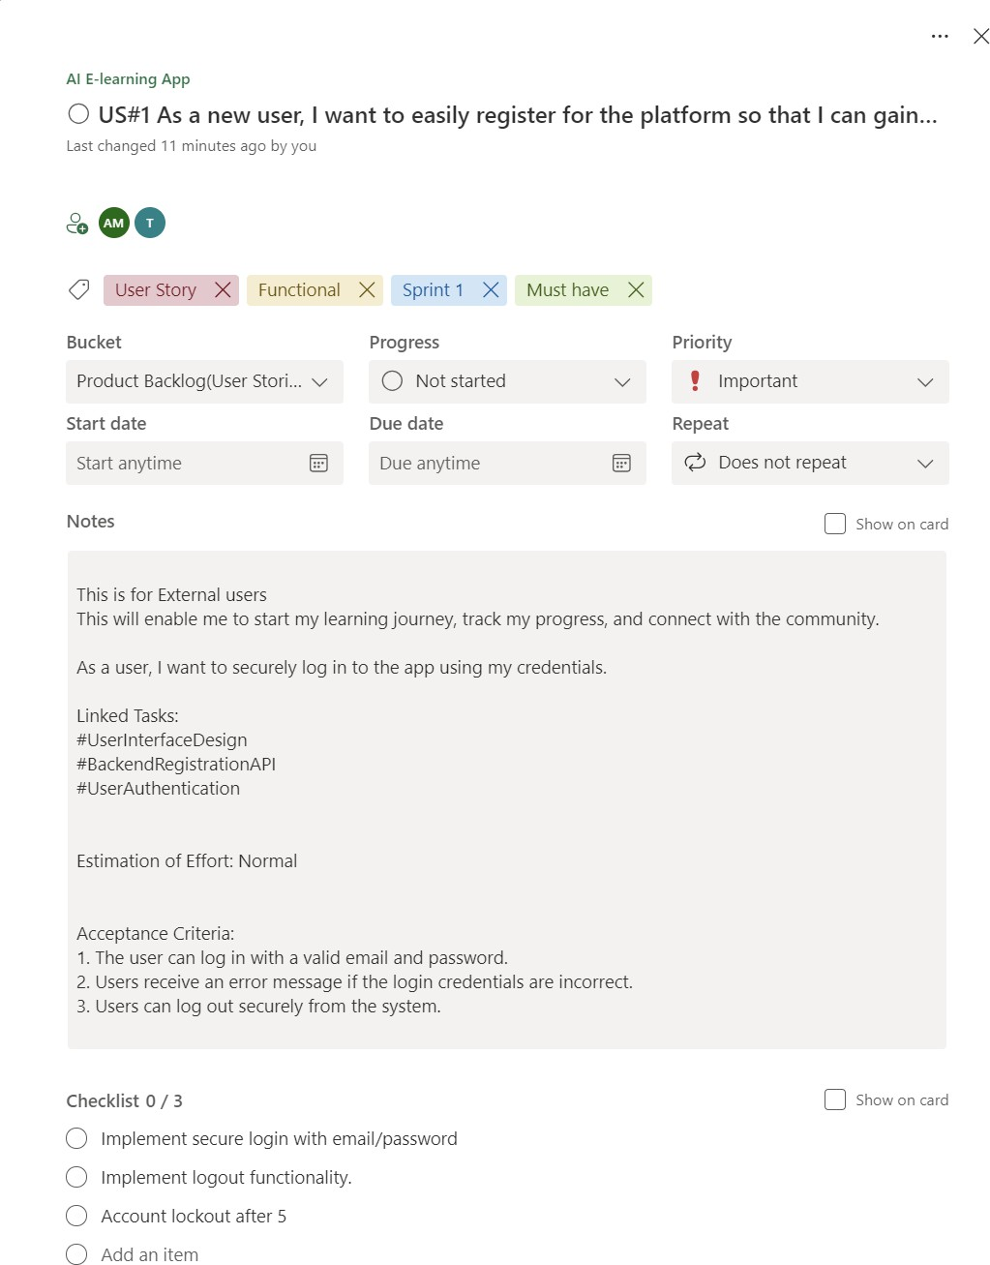

Figure 2.1 user story for user registration

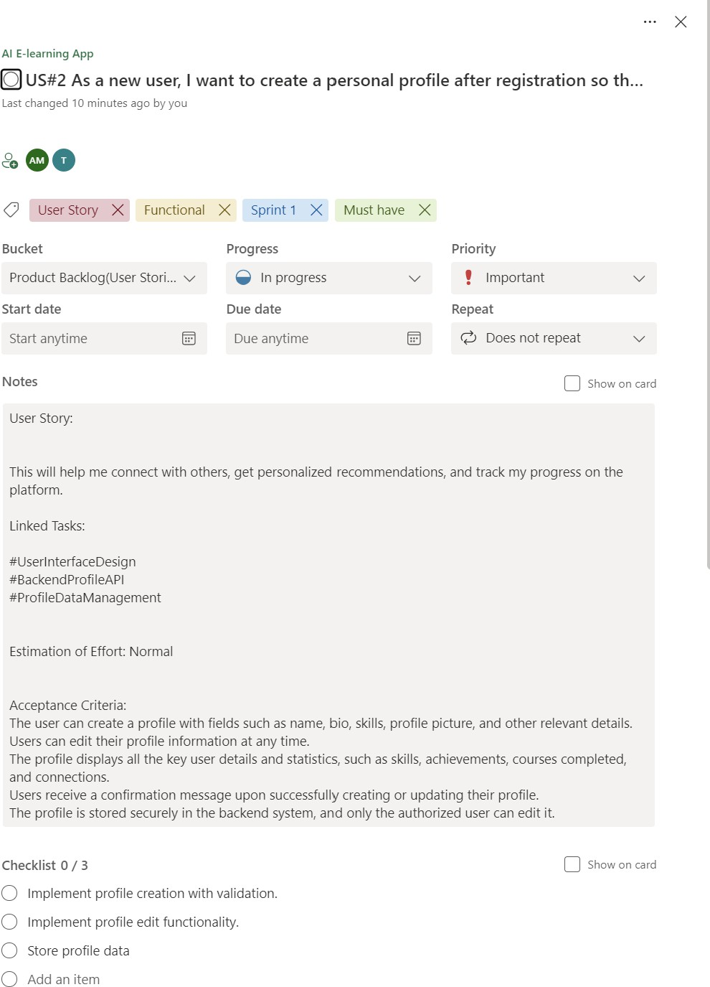

Figure 2.2 user story for profile creation

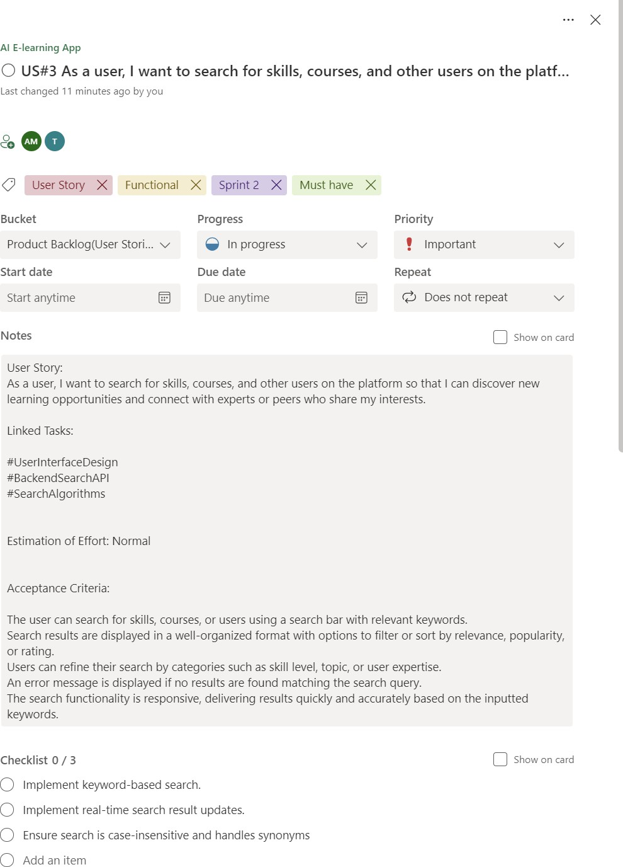

Figure 2.3 User story for search functionality

#### Functional Document

* + - 1. **Introduction**

The App Lock project aims to provide a user-focused platform that helps individuals manage gambling app usage effectively. This project focuses on delivering a secure, customizable app- locking experience, enabling real-time monitoring and notifications, and fostering a healthier digital lifestyle. The App Lock platform is designed to address the needs of users seeking to reduce or control their gambling habits through accessible, user-friendly features.

#### Product Goal

The primary goal of this project is to develop an app that empowers users to control their gambling app usage by locking selected apps, tracking usage patterns, and providing real-time notifications. The App Lock platform aims to:

* + - * + Provide secure, customizable app-locking options to restrict access to gambling apps.
        + Enable real-time access monitoring and notifications for usage awareness.
        + Offer insightful reports on app usage to promote self-awareness and support behavior change.
        + Enhance user privacy and security with robust authentication methods.

#### Demography (Users, Location) Users:

* + - * + **Target Users**: Individuals seeking to control gambling habits, parents/guardians, and therapists.
        + **User Characteristics**: Varied technical proficiency levels, diverse demographics, primarily those who wish to monitor and control app usage habits for themselves or loved ones.

#### Location:

* + - * + **Target Location**: Global, with emphasis on regions with high internet penetration and where gambling is prevalent, making the app beneficial for a broad audience seeking digital wellbeing solutions.

#### Business Processes

The key business processes include:

#### User Registration and Authentication:

* + - * + **Description**: Users can securely register and authenticate using email or phone-based methods, including options for PIN, pattern, or biometric access.
        + **Purpose**: Authentication ensures that only authorized users can access the app’s locking features and view usage reports.

#### App Detection and Locking:

* + - * + **Description**: The app detects installed gambling applications and allows users to select which apps to lock.
        + **Purpose**: Provides users with a simple and effective way to control their access to selected gambling apps.

#### Features

This project focuses on implementing the following key features:

#### Feature 1: User Registration and Profile Setup

1. **Description**:
   * The app allows new users to register and set up a secure profile with a preferred authentication method, including PIN, pattern, or biometric lock.

#### User Story:

* + *As a new user, I want to register and secure my profile so that I can access the app lock features safely.*

#### Feature 2: App Detection and Locking

1. **Description**:
   * The app automatically detects installed gambling apps on the user’s device, providing a list from which users can select apps to lock.

#### User Story:

* + *As a user, I want the app to detect gambling apps on my device so that I can easily choose which ones to lock.*

#### Feature 3: Real-time Access Notifications

1. **Description**:
   * The app provides real-time notifications for any access attempt on locked gambling apps, helping users stay aware of their interactions.

#### User Story:

* + *As a user, I want real-time notifications for access attempts on locked apps so that I am immediately informed of any usage.*

#### Feature 4: Access History and Usage Reports

1. **Description**:
   * Users can view a history of app access attempts and usage reports, showing patterns and helping them monitor their behavior over time.

#### User Story:

* + *As a user, I want to view usage reports to understand my interaction with gambling apps and support my efforts to control usage.*

#### Feature 5: Customizable Lock and Notification Settings

1. **Description**:
   * Users can customize lock options (e.g., automatic re-lock after inactivity) and notification preferences to tailor the app to their needs.

#### User Story:

* + *As a user, I want to customize lock and notification settings so that the app aligns with my usage and privacy preferences.*
    - 1. Authorization Matrix

#### Table 2.2 Access level Authorization Matrix

|  |  |
| --- | --- |
| Role | Access Level |
| Administrator | Full access to user management, app detection settings, lock configuration, and usage reporting. |
| Educator | Access to personal app locking features, real-time notifications, and usage reports |
| Learner | Access to educational content on managing digital habits, addiction control, and app usage best practices. |
| Guest User | Limited access to app features, such as browsing available settings but without access to locking functionalities. |

* + - 1. Assumptions

**The app will have access to device-level permissions required for detecting and managing gambling applications securely.**

**The development team will have ongoing access to necessary testing devices and environments to ensure the app functions seamlessly across different devices and operating systems.**

**Users and stakeholders will provide timely feedback during beta testing to refine features, improve usability, and address potential issues.**

**The app will comply with global data protection and privacy regulations, ensuring that all user data, especially regarding app usage and personal settings, is handled securely and confidentially.**

**The app will integrate with standard authentication methods (e.g., biometrics, PIN) supported by most devices to enhance security and user trust.**

## Architecture Document

* + - 1. Application Microservices:

The App Lock platform is designed with a microservices architecture, where core functionalities are managed by independent services. Key services include:

* + - * + **Authentication Service**: Manages secure user login, PIN or biometric authentication, and account recovery to ensure only authorized users access app lock functionalities.
        + **App Detection Service**: Scans the device for gambling applications and updates the list of detected apps that can be locked.
        + **App Lock Management Service**: Manages the locking and unlocking of selected apps, including configurable lock options like auto-lock after inactivity.
        + **Notification Service**: Sends real-time notifications to users for any access attempts on locked apps, helping users monitor usage.
        + **Usage Tracking and Reporting Service**: Tracks and logs app usage, generating reports on access attempts and usage patterns to support user awareness and progress tracking.
        + **Settings and Customization Service**: Allows users to configure their preferences for locking mechanisms, notification types, and report frequency.

2.1.3.2 System Architecture-

he architecture is divided into four major components:Client-side Application (User Interface, User Interaction, and Local Processing)Database (User Data, App Usage Logs, Spending Data)Third-Party APIs (Payment Systems, Gambling App Detection Services)

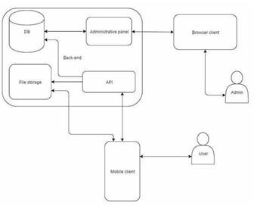

Figure 2.4 System Architecture Diagram

The mobile application acts as the user's interface with the system. It is installed on the user’s device and performs the following functions-App Locking Mechanism: (Manual Blocking)Allows users to manually lock certain gambling apps at any time if they feel the urge to gamble.. It can restrict access based on predefined rules (time spent, money spent).Spending Tracker: Tracks the amount of money the user spends on gambling apps in real time by integrating with third-party payment APIs or reading transaction notifications on the device.Usage Monitoring: Monitors the time spent on gambling apps and alerts users when they approach their predefined time or spending limits. Administrative panel: Sends behavioral notifications to users when certain thresholds (time/money spent) are reached. Alerts use cognitive-behavioral therapy (DB) techniques to prevent compulsive gambling behavior.Dashboard: Displays a summary of app usage, time spent on gambling apps, and total money spent.Spending Limit Settings: Allows users to set limits on their

spending and the time spent on gambling apps. Users can configure daily, weekly, or monthly caps.Notification Center: Displays alerts and intervention messages that warn users when they are approaching or exceeding their limits. Browser client: Stores user profiles, including spending limits, gambling app preferences, and notification settings.Spending History: Logs all financial transactions associated with gambling apps, including time and amount spent.Usage Logs: Tracks app usage history, recording time spent on gambling apps and other activities.Behavioral Data: Stores engagement data related to CBT intervention prompts, including when and how users interacted with these notifications.Encryption: All sensitive data (e.g., user profiles, spending history) is encrypted using industry-standard techniques like AES-256. Data in transit is secured with TLS.Payment API Integration:The app integrates with third-party payment APIs (e.g., Google Play, Apple Pay, or bank services) to track spending on gambling apps. Whenever a user makes a transaction related to gambling, the API logs this transaction and sends it to the backend for processing. Mobile client:The user installs the app, registers, and sets spending or time limits on gambling activities. These limits are customizable, and users can choose to set daily, weekly, or monthly caps.Tracking Spending Data:Every time the user makes a transaction on a gambling app, the app captures the transaction data (e.g., through notifications or payment API integration) and logs it in the database.Limit Exceeded– Block Activated:Once the user reaches their preset time or spending limits, the backend sends a command to the mobile app to block access to gambling apps. The app uses OS-level accessibility features to enforce the block.User Receives Interventions:Throughout the process, the app provides behavioral interventions (e.g., motivational prompts, reminders) when it detects gambling activity nearing the preset limits. If a limit is breached, more aggressive interventions are triggered.Usage and spending data are periodically synced with the backend to provide real-time analytics and reports to the user. This data is also used for refining machine learning models for better predictive accuracy.Technologies Used:Programming Languages: Kotlin/Java (Android), Swift (iOS), Python (Backend), TensorFlow (ML).Machine Learning Models: Recurrent Neural Networks (RNN), Convolutional Neural Networks (CNN).Databases: PostgreSQL, MongoDB (encrypted data storage).APIs: Google Pay, Apple Pay, gambling app detection APIs.Security: AES-256 encryption, TLS for data in transit, OAuth for authentication.

2.1.3.3. Data Exchange Contract

Frequency of Data Exchanges: Data exchanges in the App Lock project are designed to optimize performance and ensure timely access to critical information:

* Real-Time Exchanges: For essential operations like user authentication, app locking/unlocking actions, and access attempt notifications, data is exchanged in real-time via APIs to provide immediate feedback to the user and ensure seamless operation.
* Periodic Syncs: Non-critical data, such as usage history, access logs, and activity reports, is synchronized at regular intervals (e.g., daily or weekly), reducing network load while maintaining up-to-date tracking information for users.

Data Sets: The App Lock platform handles several key data sets, each with specific exchange requirements:

* User Data: Contains personal details, authentication credentials, and user preferences. This data is exchanged during login, profile updates, and security setting adjustments.
* App Data: Information about detected gambling apps, including app names and identifiers, exchanged during app detection scans and updates to ensure users have an accurate list of apps to lock.
* Usage Data: Includes data on access attempts, usage patterns, and historical usage statistics, which are exchanged periodically to update the user’s activity history and generate reports.

Mode of Exchanges (API, File, Queue, etc.): Various methods are used for data exchange across the App Lock platform:

* API: RESTful APIs handle real-time exchanges between the app’s front-end and back-end services for tasks like authentication, app locking, and notifications.
* Message Queues: Asynchronous services like RabbitMQ or AWS SQS manage background tasks, such as sending access notifications and processing activity logs, ensuring efficient performance without interrupting the user experience.
* File-Based Exchanges: Certain data, such as bulk data exports for detailed usage reports, are handled via file exchanges and stored securely on cloud storage like AWS S3, allowing users to access comprehensive activity data when needed

### UI DESIGN

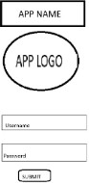

Figure 2.5 UI Design for Landing page

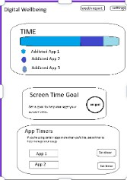

Figure 2.6 UI design for login page

## Functional Test Cases

Table 2.3 Detailed Functional Test Case

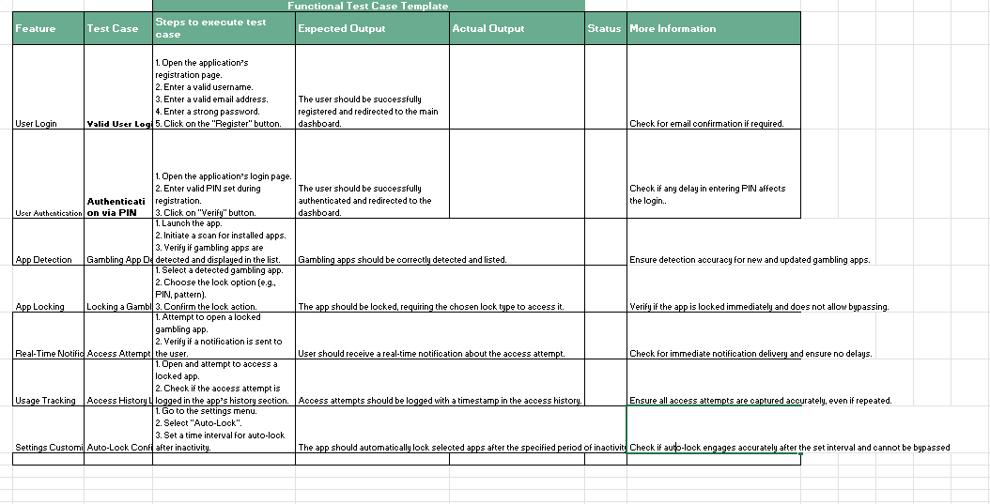

## Daily Call Progress

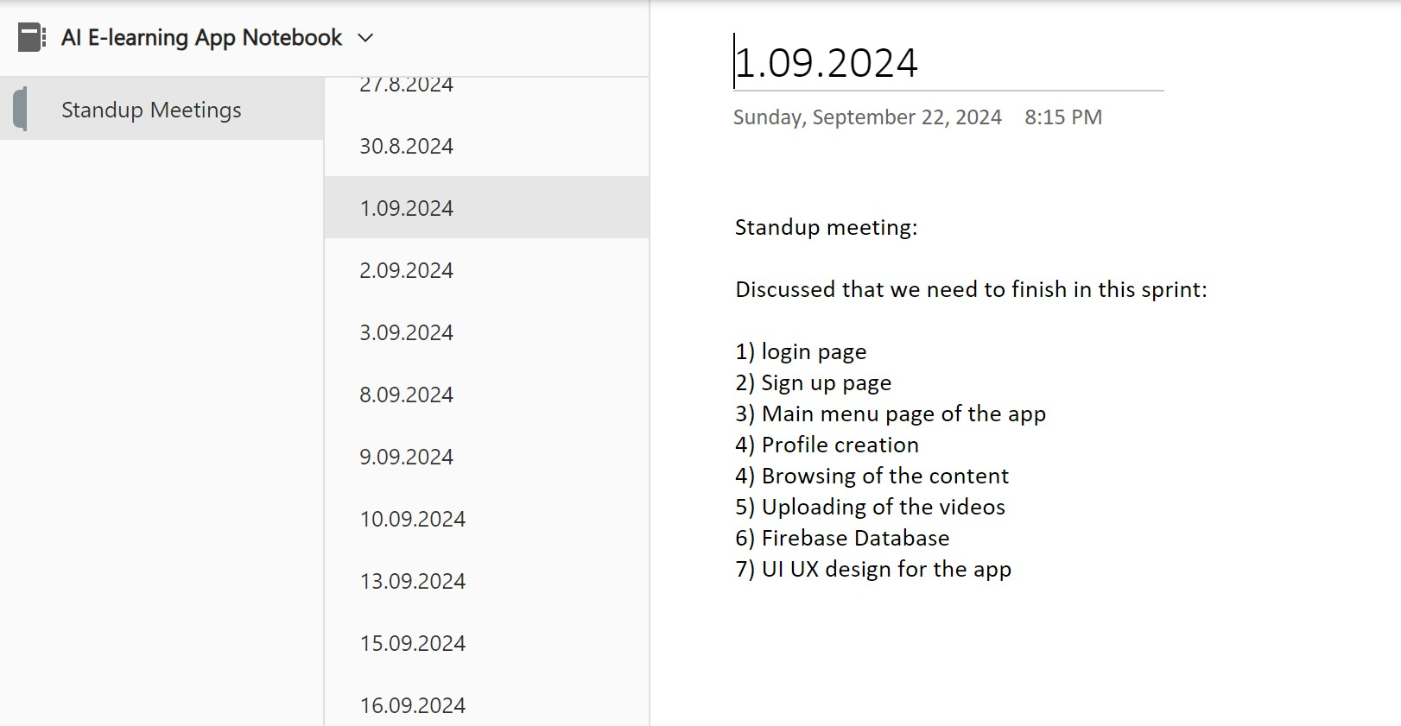

Figure 2.7 Standup meetings

## Committed Vs Completed User Stories

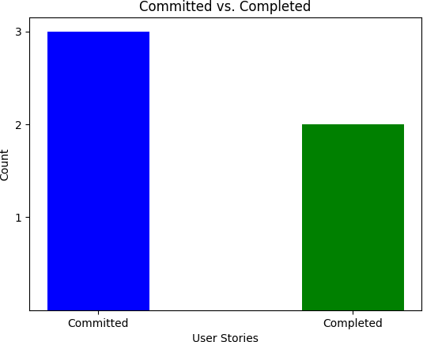

Figure 2.8 Bar graph for Committed Vs Completed User Stories

## Sprint Retrospective

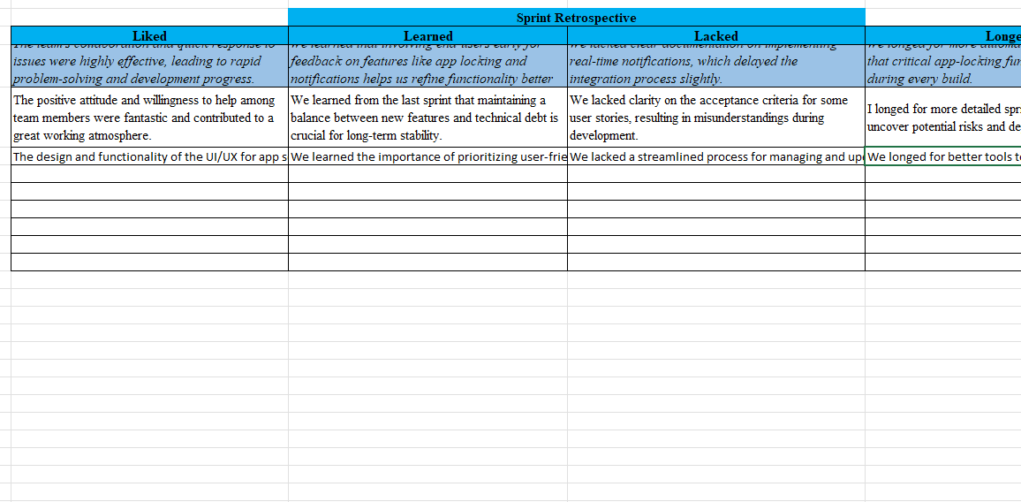Figure 2.9 Sprint Retrospective for the Sprint 1

# CHAPTER 3 RESULTS AND DISCUSSION

## Project Outcomes

The App Lock project successfully developed a user-friendly application aimed at helping individuals manage and control their usage of gambling apps. Key outcomes include:

* + 1. Effective App Locking Mechanism: The app provides users with multiple locking options, including PIN, pattern, and biometric authentication, ensuring secure access control over gambling applications.
    2. Real-Time Notifications: Users receive instant notifications upon any attempt to access locked gambling apps, keeping them aware of their usage habits and promoting mindful behavior.
    3. Comprehensive Usage Tracking and Reporting: The app logs access attempts and provides users with weekly and monthly reports on their gambling app usage patterns, supporting self-awareness and helping users make informed decisions.
    4. Customizable Settings for Personalization: Users have control over notification preferences, automatic re-locking, and lock durations, allowing them to tailor the app experience to their specific needs and habits.
    5. Enhanced Digital Wellbeing: By providing effective app-locking and tracking tools, the App Lock project contributes to improved digital

wellbeing, supporting users in their efforts to reduce compulsive app usage and manage gambling habits.

* + 1. Positive User Feedback and Adoption: Initial user feedback highlighted the app's ease of use and effectiveness, particularly the intuitive UI and responsive functionality. The app demonstrated potential for high adoption among users seeking digital wellbeing tools.
  1. **Committed Vs Completed User stories (SAMPLE)**

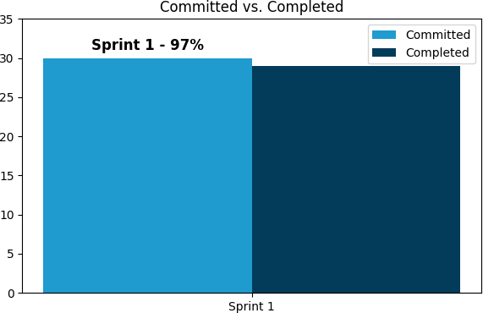

# CHAPTER 4

**CONCLUSION & FUTURE ENHANCEMENTS**

## ### Conclusion

The App Lock Project was designed to help individuals manage gambling addiction by monitoring and blocking access to gambling websites and apps. This tool provides users with a proactive and supportive environment, allowing them to restrict access to potentially harmful content while also providing insights into their app usage behavior.

Through a seamless integration of monitoring and blocking functionalities, the app serves as a valuable companion for individuals striving to take control of their online activities and foster healthier digital habits. By combining these tools with an intuitive user interface, the App Lock project offers an accessible and practical solution for managing and curbing gambling addiction.

**### Future Enhancements**

**To further support users in their journey towards digital well-being, several enhancements can be integrated into the App Lock Project:**

1. **\*\*Customizable Blocking Schedules\*\***

Allow users to set personalized blocking schedules, specifying times of day when access to gambling sites is restricted. This customization can cater to individual needs and routines, reinforcing control over their online behavior.

## **Enhanced Analytics and Insights**

Provide more detailed insights and analytics, such as trends in app usage over time, most accessed gambling apps or websites, and specific hours with high gambling app activity. This data could help users understand patterns in their behavior and progress in managing their addiction.

1. **\*\*Supportive Reminders and Motivational Messaging\*\*** Introduce reminders and motivational messages aimed at reinforcing positive behavior and encouraging continued use of the app. Regularly providing supportive messages can help users stay motivated and remind them of their goals.

## **Integration with Mental Health Resources**

Add links or suggestions for mental health resources, such as support groups, counseling services, or hotlines. This could make the app a more holistic support tool by providing users with immediate access to further help if they need it.

## **Password Protection for Settings and App Deactivation**

Implement password protection or a delay mechanism for disabling or changing the app’s settings. This would prevent impulsive disabling and provide an additional layer of control, helping users stay committed to their goals.

## **Progress Tracking and Goal Setting**

Allow users to set specific goals, such as reducing the number of times they access gambling apps per week, and track their progress over time. Gamified elements, like achievement badges, could also reinforce positive behavior and provide an encouraging experience.

## **Family and Friends Support Feature**

Include a feature where trusted family members or friends can receive notifications or weekly summaries (with user consent) to offer encouragement and accountability support.

## **Multi-Language Support**

Expand the app’s accessibility by incorporating multi-language support, allowing non-English speaking users to benefit from the app’s features, making it more inclusive and impactful.

**By continuously enhancing and adapting the App Lock project to better meet user needs, the app can become an increasingly effective tool for those committed to overcoming gambling addiction and fostering digital well-being.**

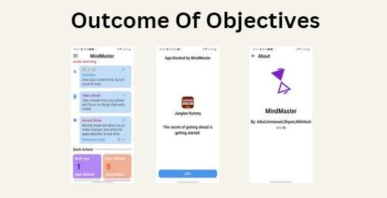

# ACKNOWLEDGMENT

This paper presented a mobile application that helps users manage their gambling habits by locking gambling apps based on time and financial constraints. By promoting self-regulation, the app has shown potential in reducing excessive gambling behaviors. Future work will focus on

improving security, adding uninstall prevention, and exploring the app's applicability in different types of addictive behavior beyond gambling.

# REFERENCES

1. Zendle, D., Cairns, P. (2021), "Adolescents and loot boxes: links with problem gambling and motivations for purchase"
2. Macey, J., & Hamari, J. (2021), “Survey Esports Research Methodology”.

3] Wardle, H. (2021), "The Emerging Adults Gambling Survey"

1. Gainsbury, S.M., & Blaszczynski, A. (2022)"The Relationship Between In-Play Betting and Gambling Problems in an Australian Context of Prohibited Online In-Play Betting”.
2. Hollén, L., & Dörner, R. (2021),“Gambling by Young Adults in the UK During COVID-19 Lockdown”
3. Kim, H.S., & Hodgins, D.C. (2022), "Self-Generated Motives of Social Casino Gamers" .
4. King, D.L., & Delfabbro, P.H. (2022), "Reconsidering item response categories in gaming disorder symptoms measurement”.
5. Hing, N., & Russell, A.M.T. (2021),"The COVID-19 lockdown experience suggests that restricting the supply of gambling can reduce gambling problems: An Australian prospective study”.
6. Brooks, G.A., & Clark, L. (2022),"Gambling along the schizotypal spectrum: The associations between schizotypal personality, gambling- related cognitions, luck, and problem gambling" .
7. Mills, D.J., & Nower, L. (2021),"Implications of the Increasing Convergence of Video Gaming and Gambling”.

# APPENDIX A.SAMPLE CODING

To detect running apps, you need to declare some permissions in the AndroidManifest.xml:

xml

Copy code

<manifest ...>

<uses-permission android:name="android.permission.PACKAGE_USAGE_STATS"/>

<uses-permission android:name="android.permission.SYSTEM_ALERT_WINDOW"/>

<application ...>

<!-- Add other components here -->

</application>

</manifest>

## 2. UsageStatsManager for Monitoring App Usage

In Android, you can use the UsageStatsManager to monitor and detect active apps.

## Sample Code for Monitoring and Blocking Apps

Here's a simple setup where the app detects if a certain app (e.g., a gambling app) is running and then blocks access by displaying an overlay.

## MainActivity.kt

kotlin Copy code

import android.app.AppOpsManager import android.app.usage.UsageEvents

import android.app.usage.UsageStatsManager import android.content.Context

import android.content.Intent import android.os.Bundle import android.provider.Settings import android.widget.Toast

import androidx.appcompat.app.AppCompatActivity

class MainActivity : AppCompatActivity() {

// List of apps to block

private val blockedApps = listOf("com.example.gamblingapp")

override fun onCreate(savedInstanceState: Bundle?) { super.onCreate(savedInstanceState) setContentView(R.layout.activity_main)

// Check for usage permission and request if not granted if (!hasUsagePermission()) {

requestUsagePermission()

} else {

// Start the AppMonitorService to monitor app usage startService(Intent(this, AppMonitorService::class.java))

}

}

private fun hasUsagePermission(): Boolean {

val appOps = getSystemService(Context.APP_OPS_SERVICE) as AppOpsManager

val mode = appOps.checkOpNoThrow( AppOpsManager.OPSTR_GET_USAGE_STATS, android.os.Process.myUid(), packageName

)

return mode == AppOpsManager.MODE_ALLOWED

}

private fun requestUsagePermission() {

Toast.makeText(this, "Please grant usage access permission", Toast.LENGTH_LONG).show()

startActivity(Intent(Settings.ACTION_USAGE_ACCESS_SETTINGS))

}

}

## AppMonitorService.kt

This service will continuously monitor the active app and block access to any apps in the blockedApps list.

kotlin Copy code

import android.app.Service

import android.app.usage.UsageEvents import android.app.usage.UsageStatsManager import android.content.Context

import android.content.Intent

import android.os.Handler import android.os.IBinder import android.widget.Toast

class AppMonitorService : Service() {

private val blockedApps = listOf("com.example.gamblingapp") private lateinit var usageStatsManager: UsageStatsManager private val handler = Handler()

override fun onCreate() {

super.onCreate() usageStatsManager =

getSystemService(Context.USAGE_STATS_SERVICE) as UsageStatsManager

startAppMonitoring()

}

private fun startAppMonitoring() { handler.postDelayed(object : Runnable {

override fun run() {

val currentApp = getForegroundApp()

if (blockedApps.contains(currentApp)) { showBlockedOverlay()

}

handler.postDelayed(this, 1000) // Check every second

}

}, 1000)

}

private fun getForegroundApp(): String? { val endTime = System.currentTimeMillis() val startTime = endTime - 1000 * 60

val usageEvents = usageStatsManager.queryEvents(startTime, endTime)

var lastApp: String? = null

while (usageEvents.hasNextEvent()) { val event = UsageEvents.Event() usageEvents.getNextEvent(event)

if (event.eventType == UsageEvents.Event.MOVE_TO_FOREGROUND) {

lastApp = event.packageName

}

}

return lastApp

}

private fun showBlockedOverlay() {

val overlayIntent = Intent(this, BlockedOverlayActivity::class.java) overlayIntent.addFlags(Intent.FLAG_ACTIVITY_NEW_TASK) startActivity(overlayIntent)

}

override fun onBind(intent: Intent?): IBinder? {

return null

}

}

## BlockedOverlayActivity.kt

This activity will display an overlay screen whenever a blocked app is launched.

kotlin Copy code

import android.os.Bundle

import android.view.WindowManager

import androidx.appcompat.app.AppCompatActivity

class BlockedOverlayActivity : AppCompatActivity() {

override fun onCreate(savedInstanceState: Bundle?) { super.onCreate(savedInstanceState) setContentView(R.layout.activity_blocked_overlay)

// Make the activity appear over the blocked app

window.setType(WindowManager.LayoutParams.TYPE_APPLICATION

_OVERLAY)

}

override fun onBackPressed() {

// Prevents the back button from exiting this overlay

moveTaskToBack(true)

}

}

## activity_blocked_overlay.xml

Design a simple overlay layout with a message for the blocked app screen: xml

Copy code

<RelativeLayout xmlns:android="<http://schemas.android.com/apk/res/android>"

android:layout_width="match_parent" android:layout_height="match_parent" android:background="@android:color/holo_red_dark">

<TextView android:id="@+id/blocked_message" android:layout_width="wrap_content" android:layout_height="wrap_content" android:layout_centerInParent="true"

android:text="This app is blocked!" android:textColor="@android:color/white" android:textSize="24sp" />

</RelativeLayout>

## Explanation:

1. **Permissions**: The app requests PACKAGE_USAGE_STATS to detect the currently running app and SYSTEM_ALERT_WINDOW to display overlays.
2. **MainActivity**: Starts AppMonitorService if permission is granted.
3. **AppMonitorService**: Uses UsageStatsManager to detect the current foreground app and checks if it’s in the blockedApps list. If it’s blocked, it launches BlockedOverlayActivity.
4. **BlockedOverlayActivity**: Shows an overlay with a blocking message, preventing the user from interacting with the blocked app.

This is a basic setup that should give you a foundation for creating your App Lock functionality.

**B.PLAGIARISM REPORT**

